HELP TO HOPE

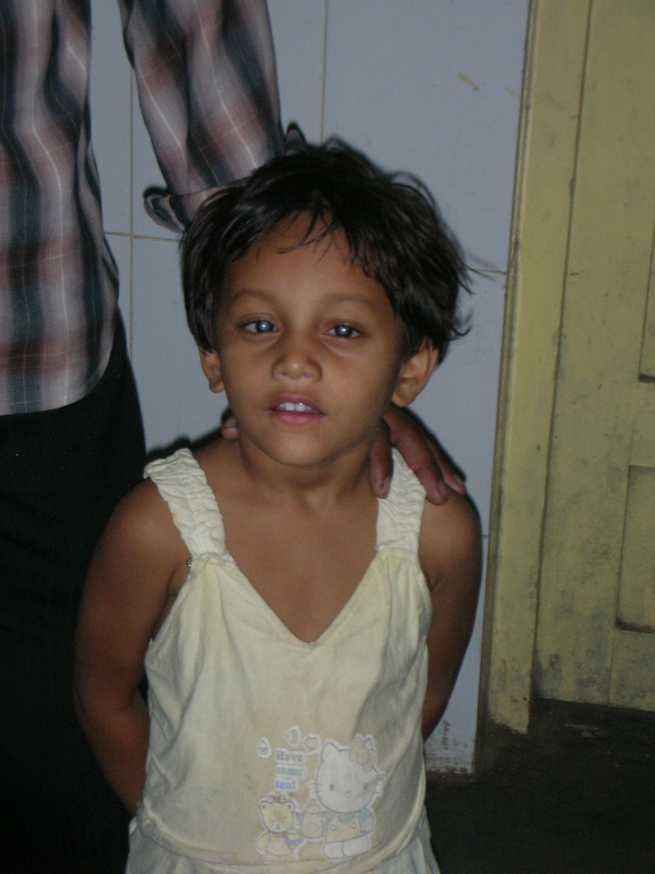

Name of the Patient: Muktya Sneha

Father name: Muktya Ramesh

DOB / Age: 5 years

Permanent Address:

Street / Village: Srirmagiri

Mandal / District: Enkoor - Khammam

Pin code: -

Phone No: -

Address for Correspondence:

H.No:
Street / Village:
Mandal / District: “ same as above “
Pin code:
Phone No:

Information Regarding Social Economic Status:

Nuclear / Combined Family: Nuclear Family

Ration Card / Income Certificate: White Ration Card

Any amount was sanctioned than any organization: CMRF

Earning Members:
Names:

- M. Ramesh

- M.Komaramma

Occupation: cooly

Income: Rs. 2000/- per month

House:

- Placed: village

- Type: Hut

- Toilets: no

- TV no

- Fridge: no

- Motor Vehicles: no

- Types: cycle

DISEASE INFORMATION
( To be filled by Doctor )

Diagnosis: Cataract

Date of Diagnosis: January ‘ 2006

KMF has provided both medical and financial help to Muktya Sneha - a 5 years old girl - to have EYE SIGHT RESTORATION SURGERY. Muktya Sneha, d/o Ramesh, Sriramagiri Village, Enkoor Mandal, Khammam Dt, A.P became blind because of cataract in both eyes when she was 3 years of age. Her parents took her Hyderabad. Her father told us that hospital in Hyderabad has done some tests, gave her a prescription and sent her back home with out providing any information. Parents used those medicines and thought she is blind.
When we have conducted medical camp on 28th Jan 2008 in Sriramagiri, her parents brought her over there. KMF brought Sneha to Sarojini Devi Eye Hospital in Hyderabad. Dr. Lokabhi Reddy, an eye specialist in that hospital and also he is closely working with KMF, took care of tests and arranged for surgery. Surgery was done on 26-Feb-2008, yesterday, today she had post surgery vision tests and the result is good.

