HELP TO HOPE
Form filled by : A.ANIL KUMAR - UHBD 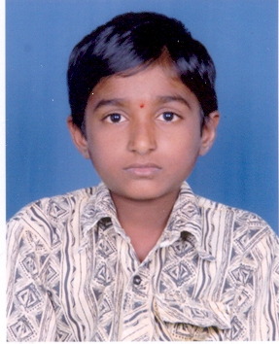

Information provided by : Mogili Satyam

Name of the Patient: Mogili Laxman

Father / Husband name: Mogili satyam

DOB / Age: 7 ½ years

Permanent Address:

H.No: 6-25

Street / Village: Ashok Nagar

Mandal / District: Khanapur - Warangal

Pin code: -

Phone No: -

Address for Correspondence:

H.No:
Street / Village:
Mandal / District: “ same as above “
Pin code:
Phone No:

Information Regarding Social Economic Status:

Nuclear / Combined Family: Nuclear Family

Ration Card / Income Certificate: White Ration Card

Any amount was sanctioned than any organization: CMRF

Earning Members:
Names:

- M.Satyam

- M.Komaramma

Occupation: cooly

Income: Rs. 3000/- per month

House:

- Placed: village

- Type: Hut

- Toilets: no

- TV no

- Fridge: no

- Motor Vehicles: no

- Types: cycle

Education

Father: nil

Mother: 7th class

Children: 3 childrens

Name Age Class / Degree School / College

1. M.Manasa 12 6th class school

2. M.Laxman 7 2nd class school

3. M.Aravind 5 LKG school

4.

Child / Adult:

Interest:

- Books: story books

- Sports: cricket

- Movies: TV, All types of movies

Parents / Guardian name & signature :

DISEASE INFORMATION
( To be filled by Doctor )

Diagnosis: Acute Lymphoblastic Leukemia ( ALL )

Date of Diagnosis: January ‘ 2005

Investigations:

- CBP Hb 6.7 WBC 7000 PLT 20,000
- Bone Marrow
- Histo Pathology ALL
- Others

Treatment Protocol: Schedules

- Induction Form Jan’05 To Feb’05

- Consolidation From Feb’05 To March ‘ 05

- Re – induction From May’05 To June’05

- Re – Induction From Sep’05 To Nov’05

- From To

Treatment Completed:

Reviews:

4.

Name of Disease: Acute Lymphoblastic Leukemia

Type of Treatment: Chemo Therapy

Estimation Amount:

Any amount was sanctioned than any organization:

Recommendations: Rs.5,000

Consultant Name : Dr.Ramana Dandamudi

Consultant Signature :

