HELP TO HOPE
Form filled by : A.Anil Kumar - UHBD 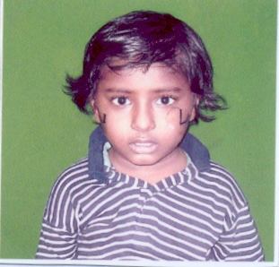

Information provided by : D.Rambabu - Father

Name of the Patient: D.Vijaya kumar

Father / Husband name: D.Rambabu

DOB / Age: 02- 09 –2001 7 years

Permanent Address:

H.No: 3 –78 B

Street / Village: Metlapalle

Mandal / District: Gannavaram, Krishna ( dt )

Pin code: -

Phone No: -

Address for Correspondence:

H.No:
Street / Village:
Mandal / District: “ same as above “
Pin code:
Phone No:

Information Regarding Social Economic Status:

Nuclear / Combined Family: combined family

Ration Card / Income Certificate: WAP062103300163

Any amount was sanctioned than any organization: CMRF Rs.40,000

Earning Members:
Names:

- D.Rambabu

Occupation: cooly

Income: 1000 – 1500 /- per month

House:

- Placed: village

- Type: Daba

- Toilets: western type

- TV no

- Fridge: no

- Motor Vehicles: no

- Types: no

Education

Father: 5 th class

Mother: 5 th class

Children: 1 LKG

Name Age Class / Degree School / College

1. D.Vjaya Kumar 6 LKG School

2.

3.

4.

Child / Adult:

Interest:

- Books: Drawing books , cartoons, comics

- Sports: nil

- Movies: All types of movies

Parents / Guardian name & signature :

DISEASE INFORMATION
( To be filled by Doctor )

Diagnosis: Acute Lymphoblstic Leukemia

Date of Diagnosis: 06.11.07

Investigations:

- CBP Hb 4.3 WBC 2600 PLT 38000
- Bone Marrow ALL L2
- Histo Pathology
- Others

Treatment Protocol: Schedules

- Induction Form 06.11.07 To 17.12.07

- Consolidation From 17.12.07 To

- Re – induction From To

- Re – Induction From To

- From To

Treatment Completed:

Reviews:

4.

Name of Disease: Acute Lymphoblastic Leukemia ( ALL )

Type of Treatment: Chemo Therapy

Estimation Amount: 2, 20, 000/-

Any amount was sanctioned than any organization: 40,000/- CMRF

Recommendations: 30,000/-

Consultant Name : Dr.D.V.Ramana

Consultant Signature :

