KMF/T has started activities with holistic approach in Sriramagiri panchayat, Enkoor Mandal, Khammam District by conducting a Free health camp on 27th Jan 2008, which was a big success

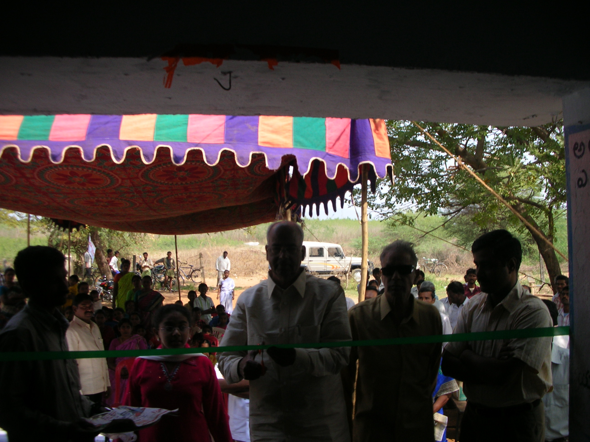

Dr. R. Venkateswara Rao – Inagurating the camp.

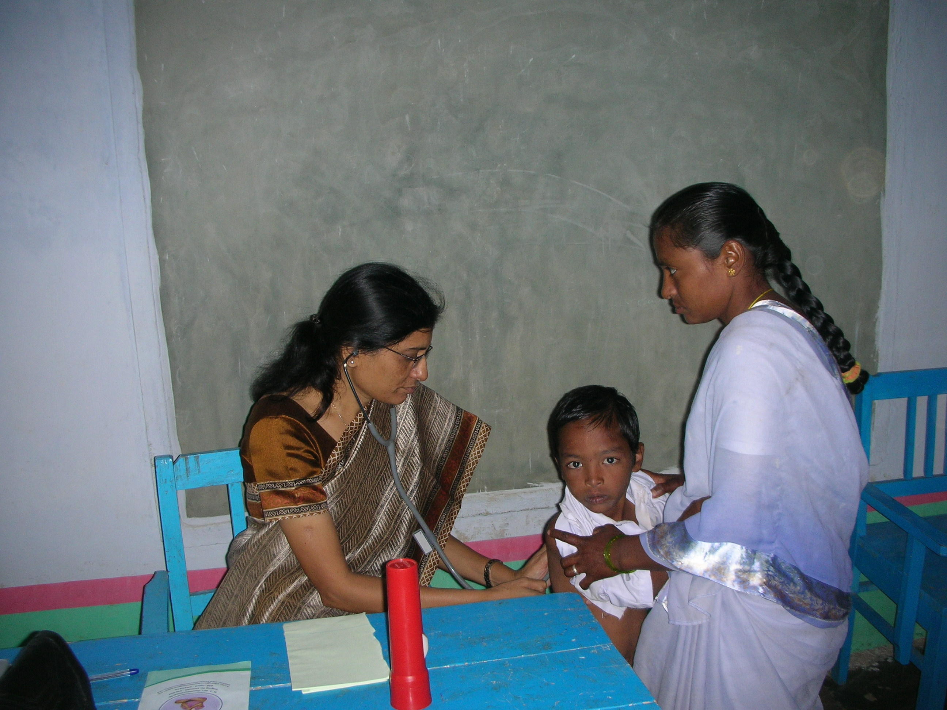

Dr. Y. Nagamani – taking care of a patient.

Mr. K. Ravindra Rao, advocate, Vijayawada, managing trustee, Kinnera Memorial Trust has opened KMT office in Sriramagiri.

Doctors attended the camp:
Dr. R.Venkateswara Rao from Vijayawada, a senior pediatrician has inaugurated the camp
Dr. Y. Nagamani, Pediatrician, Khammam
Dr. V. Radhakrishna Murthy, Hyderabad
Dr. B. Srikanth, Pediatrician, Khammam
Dr. Srinivasa Naidu, Pediatric Dentist, Hyderabad

KMF/T have started our activities with holistic approach in Sriramagiri panchayat, Enkoor Mandal, Khammam Dtistrict. We have organized a free health camp on 27th Jan 2008 in Sriramagiri village. We have got very good response from all the three villages in Sriramagiri Panchayat, we have provided free medicines and other medical services to all 250 children who camp to the camp. We also have opened an office in that village.
Doctors have identified
1. A child with Blood Disorder, bringing to Hyd for further tests and treatment
2. A child with heart problem, bringing this kid to Hyd for further tests and treatment
3. two kids are blind because of cataract, we are bringing these two kids to Max Vision Eye Hospital for further tests and surgery
4. Four kids with some unknown serious problem, we are taking care of this kid by getting all the scans and tests done in Khammam town.
Doctors have identified kids with malnutrition, and recommended us to take follow up action. We are planning to have a meeting with doctors and other NGOs to work on this issue.\
Doctors also have identified kids with Fluoride in water related problems; we are also planning to work on this issue.
We are conducting a competition on Hygiene and cleanliness which was suggested by our friend Satya Chadalawada. Villagers who are interested in this competition have to register with KMT; KMT representatives make surprise visits to their homes next three months and check whether they are keeping home and its surrounding areas as per those guidelines we have provided. First prize winner will get Rs.5000, second Rs. 2000 and third Rs.1000 when we organize our next camp after 3 months.

